Bank of America

Visualizing the Behavior of a Complex System

Project Sponsor: *Michael Karafotis*

Project Mentor: *John Leonard*

Team Members:

*Saurav Chatterjee*

*Brian Zhang*

*Zachary Stephens*

Proposal Outline

1. Executive Summary
2. Introduction
   1. Background
   2. Purpose
   3. Scope
3. Discussion
   1. Approach
4. Resources
   1. Personnel
   2. Facilities and Equipment
   3. Cost
5. Conclusion
   1. Summary
   2. Contacts

Executive Summary

Bank of America comprises of numerous businesses and thousands of different applications, services, and other processes underneath those businesses. Those applications, services, and many other sub-branches underneath the business may have dependencies between them. A real-world example would be if a service has an error, an application that relies on that service may start having issues, which may have an impact on other applications. There are thousands of such applications, services, infrastructure, processes that have these links between them. The goal of this project is to *visualize these relationships in a clear and concise platform and allow to see the impact of the connections*. A key performance indicator (KPI) will be used to measure how well an application, or service is running. The KPI is going to be different depending on what is being measured, however, that is just to be defined as either ‘good’ or ‘bad’ depending on a fixed threshold. A practical application of this visualization will allow managers and developers to monitor if there are any concerns or allow them to see who to contact if they do have a concern. The limitation of this project is that it’s going to be a concept. The visualization tool will be a framework that can be expanded to encompass Bank of America’s needs. The information in the development of the project is not necessarily Bank of America’s.

Introduction

Background

Before we explore the purpose of the project, it’s important to understand *why* this project was proposed. Bank of America has many different businesses that meet different demands. The business is the culmination of various applications, services, processes, that work smoothly. Many of these applications, services, processes, and other have relationships between them. A service may help an application, or a process may feed into a service. If one stops performing, then the application, or service may encounter problems. This impacts the performance, which starts piling up. Many applications are easier to detect problems in. If an application that is used by customers goes down, then it becomes apparent quick because of the complaints. However, many applications and services are harder to detect faults in. Many of them may have numerous processes that are inputs. To see a simple example, refer to figure 1. If service 2 goes down, then it impacts not only service 1, but application 1 as well. This then impacts application 2. In this case, application 2 would be the highest in the application hierarchy because application 1 helps in the functionality of application 2. So even one error in a service can have a ripple effect throughout a business.

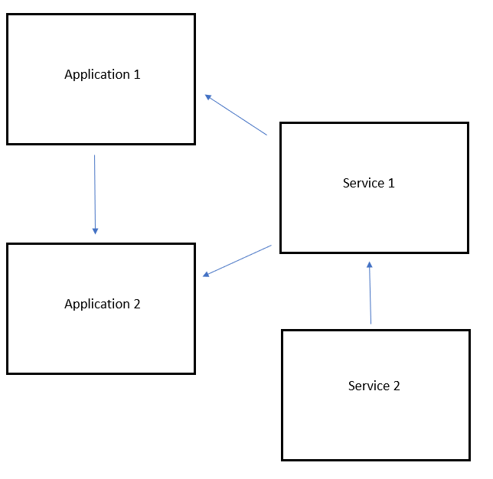

Figure 1: Simple relationships between applications and services.

Purpose

We have established that there are many relationships in a business that help in it function smoothly. The problem is: *there is no suitable way to currently view all these relationships in a meaningful way.* The purpose of this project is *to visualize these relationships in a clear and concise platform and allow to see the impact of the connections*. The visualization will aid in figuring out information associated with different applications and services. Along with those functionalities, a key component will be in assessing the impact of KPI’s on the visualization. Further details of the KPI will be covered in the scope section.

Scope

The scope will allow the team to focus on the important aspects of the project. This project, however, only is intended as a framework of a visualization tool. This is NOT the exact visualization that will be used by Bank of America.

Scope objectives:

* All applications, services, infrastructure, processes, etc. will be shown as nodes.
* Relationships in the visualization will show the direction of flow.
* The visualization will be expandable so that the tool can be used, but the data can be changed without too much effort.
* Nodes and relationships can be filtered, showing only some aspects of the visualization.
* Filter by group (ex: application)
* Nodes show useful information when clicked.
* KPI’s are displayed and are used to indicate the status of nodes.
* For example, nodes turn red if a certain KPI goes into a “bad” value.

Assumptions:

* Building the model on a basis of a normal Business/infrastructure model.
* Data used in the visualization is randomly generated.
* The relationships that will be portrayed between various nodes do not reflect real-life practices, or any meaningful information. They will be assigned randomly.

Exclusions:

* Real data pertaining to Bank of America. This means that none of the data in the visualization model is related to Bank of America.

Known issues:

* There are many different languages and tools we can use to develop the visualization.

Discussion

Approach

Our approach as of right now has been focusing on discovering and learning different technologies and tools. We also have a focus on gathering requirements and creating different use cases for the visualization tool. The team has some experience with working with tools for creating the visualization. However, for the scale and complexity of the project, it nearly isn’t enough. Our first goal is to consider different possible routes we can take to complete the deliverables on time.

Our approach will resemble the steps below, but obviously as the project and our understanding of it changes, so might the steps:

1. Get an overview of the project.
2. Learn more about the structure of BoA.
3. Gather requirements and understand the scope of the project.
4. Gather information about potential tools and technologies that might aid in the project.
5. Learn more about the chosen tools/technologies.
6. Implement some small-scale demos using the tools and technologies.
7. Make any changes through feedback.
8. Keep making the implementations more complex after each iteration.

This is a very simple plan to begin the design of the project. Also, these steps are not necessarily linear, as it is very likely we will drop and pick tools and technologies throughout the project. However, it is important to run through any changes with our sponsor and mentor.

To accomplish this, we have a plan to keep constant communication. The team will aim to meet with Mr. Karafotis, project sponsor, bi-weekly if possible. The mode of communication can be face-to-face meetings, WebEx, or emails. The constant communication will allow the team to get any feedback as soon as possible about the direction of the project. This is especially important during the 1st half of the project as that will be the design phase of the project. We will also have meetings with our mentor, John Leonard every week at the weekly Bank of America status update meeting. This will allow the team to update and get feedback at the same time. We will also try to maintain constant communication with any additional experts that we meet.

Resources

Personnel

Currently we have:

*Michael Karafotis – Project Sponsor*

*John Leonard – Project Mentor*

*Harvey Summers – Subject Expert*

*Saurav Chatterjee – Development Team*

*Brian Zhang – Development Team*

*Zachary Stephens – Development Team*

*Robert Dahlberg – Professor / Expert*

Facilities and Equipment

As of right now, no outside facility, or physical equipment will be needed. However, there is going to be potential software licenses we will need in the future.

Resource volume:

* Python
* JavaScript
* D3 Library
* Observable
* Neo4j
* Node

These are some of the technologies we have identified to be useful in the project. This list can very well change as the project progresses.

Cost

The current cost we have identified is for multiple Observable premium accounts. Starting from mid-January, we will be getting premium accounts that will allow us to collaborate on code and make quicker edits. The cost for a premium account for a single person is $9.99, which we need 3 of. This will amount to $29.97 every month for a duration of 5 months. The total will come to approx. $150. We might need a server/database, but as of right now, that is not confirmed so it’s not being included.

Conclusion

Summary

Bank of America has many businesses that have many layers underneath them as we have discussed. This project is focused on creating a visualization tool that will help in viewing the different relationships in the various businesses. The resulting visualization tool will assist Bank of America in creating their own visualization once they chose to do so. The visualization tool will allow for multiple views and different use cases, such as a high-level view for executives and graphs for more in-depth information.

Contacts

Michael Karafotis – michael.karafotis@bofa.com

John Leonard – jdleonard@vcu.edu

Harvey Summers – harvey.summers@bofa.com

Saurav Chatterjee – chatterjees3@vcu.edu

Brian Zhang – zhangb8@mymail.vcu.edu

Zachary Stephens – stephenszc@mymail.vcu.edu

Robert Dahlberg – [dahlbergra@vcu.edu](mailto:dahlbergra@vcu.edu)

Sheryl Jordan - sheryl.jordan@bofa.com